
Arab Academy for Science, Technology, and Maritime Transport
College of Engineering – Computer Engineering Dept.
Course | ECE3403 – Data Analytics & Optimization
Lecturer | Dr. Karma Fathalla – Dr. Doaa Shoieb
TAs | Yasmina Ayman – Hoda Osama – Marwan Nour

Sheet 1 - Introduction to Data Science and Optimization Concepts and Tools

Question 1:
Format the following example to:
- Create Markdown cells in Jupyter Notebook and format it using different Markdown elements.
- Create a Code cell and write a simple Python Code. Define two variables for course name and course code, then print “Let's start first section in ECE3403 - Data Analytics and Optimization”
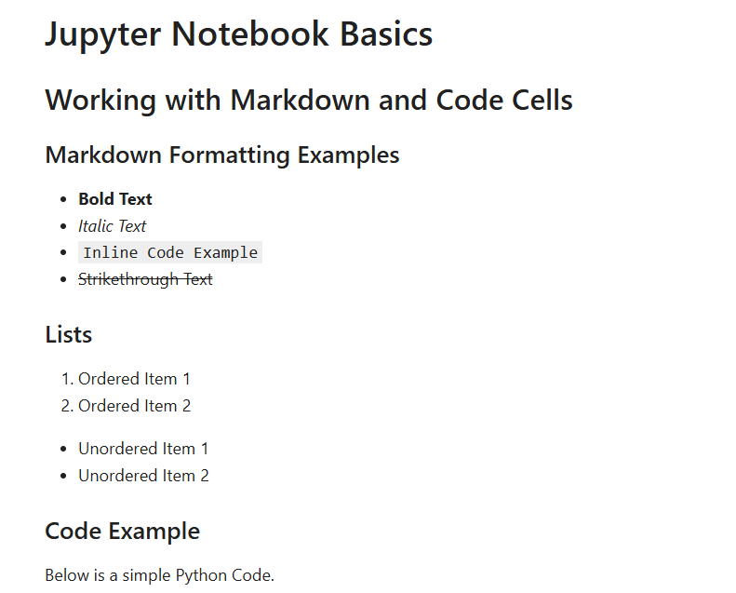

Question 2:
Create a 3 × 3 NumPy ndarray containing consecutive integers from 1 to 9 (inclusive). After creating the array, perform the following tasks:
- Print the following properties of the array (Data type, Shape, Size)
- Retrieve the element in the second row, third column
- Update the entire first row to [10, 11, 12]
- Delete the second row
- Delete the last column
- Append the row [13, 14]
- Append the column [1, 2, 3]
- Insert a new column [20, 30, 40] as the second column
- Use Boolean indexing to extract only the odd numbers from the array.
- Create another 2D array arr2D_2 = np.array([[10, 20, 30, 40], [50, 60, 70, 80]]), then vertically stack both of the arrays.
- Create a copy of the original array, then slice this copy to extract the first two rows and last two columns
- Find and display the unique elements in the original array

Question 3:
Given the following lists:
books = ['Great Expectations', 'Of Mice and Men', 'Romeo and Juliet', 'The Time Machine', 'Alice in Wonderland']
authors = ['Charles Dickens', 'John Steinbeck', 'William Shakespeare', 'H. G. Wells', 'Lewis Carroll']
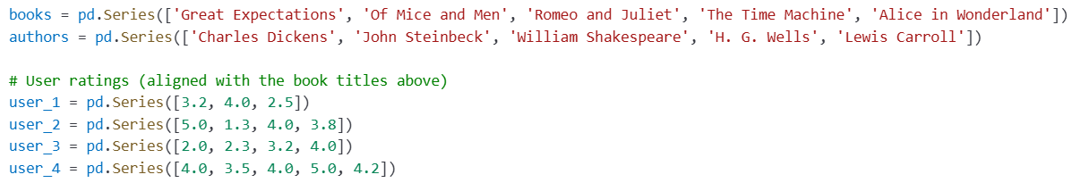
- Create a Pandas Series from books and authors list.
- Create a dictionary using the given data where:
- The keys are 'Author', 'Book Title', 'User 1', 'User 2', 'User 3', and 'User 4'.
- The values are the corresponding Series objects.
- Create a Pandas DataFrame from the dictionary, allowing Pandas to automatically assign numerical row indices.
- Print key attributes of the DataFrame: The shape, number of dimensions, total elements, values, index, and column names.
- Display only the 'Book Title' and 'Author' columns.
- Display the first three rows of the DataFrame.
- Insert a new column 'Average Rating' that represents the average rating across all users for each book.
- Append a new row for the book "Pride and Prejudice" by "Jane Austen", with ratings [4.5, 4.0, 3.8, 4.9].
- Rename the column 'Book Title' to 'Title'

